Bagging Ensemble - Predictions on New Data
Generated: 2026-05-29 10:27:33

Predictions
Index | CustomerID | Age | Income | PreviousPurchases | AvgOrderValue | DaysSinceLastPurchase | EmailOpensLast30d | ClicksLast30d | TimeOnSiteMin | IsWeekendPurchase | HasActiveSubscription | NumSupportTickets | SocialMediaFollower | Predicted_Class | Probability_0 | Probability_1
0 | 1001.0 | 35.0 | 75000.0 | 12.0 | 89.5 | 15.0 | 8.0 | 12.0 | 45.2 | 0.0 | 1.0 | 1.0 | 250.0 | 0.0 | 1.0 | 0.0
1 | 1002.0 | 28.0 | 52000.0 | 5.0 | 45.3 | 45.0 | 3.0 | 4.0 | 23.1 | 0.0 | 0.0 | 0.0 | 45.0 | 0.0 | 0.63 | 0.37
2 | 1003.0 | 42.0 | 125000.0 | 28.0 | 145.0 | 3.0 | 15.0 | 24.0 | 78.5 | 1.0 | 1.0 | 0.0 | 1200.0 | 1.0 | 0.02 | 0.98
3 | 1004.0 | 31.0 | 68000.0 | 8.0 | 67.2 | 22.0 | 6.0 | 7.0 | 34.8 | 0.0 | 0.0 | 2.0 | 180.0 | 0.0 | 1.0 | 0.0
4 | 1005.0 | 55.0 | 95000.0 | 15.0 | 92.5 | 8.0 | 10.0 | 11.0 | 52.3 | 0.0 | 1.0 | 1.0 | 450.0 | 0.0 | 0.99 | 0.01
5 | 1006.0 | 24.0 | 38000.0 | 2.0 | 35.0 | 60.0 | 2.0 | 1.0 | 12.5 | 1.0 | 0.0 | 3.0 | 25.0 | 0.0 | 1.0 | 0.0
6 | 1007.0 | 48.0 | 150000.0 | 35.0 | 210.0 | 1.0 | 25.0 | 35.0 | 95.2 | 1.0 | 1.0 | 0.0 | 2500.0 | 1.0 | 0.0 | 1.0
7 | 1008.0 | 29.0 | 45000.0 | 4.0 | 42.8 | 35.0 | 4.0 | 3.0 | 28.4 | 0.0 | 0.0 | 1.0 | 90.0 | 0.0 | 1.0 | 0.0
8 | 1009.0 | 38.0 | 82000.0 | 11.0 | 78.3 | 12.0 | 9.0 | 14.0 | 48.6 | 0.0 | 1.0 | 0.0 | 320.0 | 1.0 | 0.08 | 0.92
9 | 1010.0 | 45.0 | 110000.0 | 22.0 | 125.0 | 5.0 | 18.0 | 22.0 | 68.9 | 1.0 | 1.0 | 0.0 | 890.0 | 1.0 | 0.0 | 1.0
10 | 1011.0 | 26.0 | 41000.0 | 3.0 | 38.5 | 50.0 | 3.0 | 2.0 | 18.2 | 0.0 | 0.0 | 2.0 | 35.0 | 0.0 | 1.0 | 0.0
11 | 1012.0 | 52.0 | 135000.0 | 31.0 | 168.0 | 2.0 | 20.0 | 28.0 | 82.4 | 0.0 | 1.0 | 0.0 | 1750.0 | 1.0 | 0.0 | 1.0
12 | 1013.0 | 33.0 | 62000.0 | 9.0 | 72.4 | 18.0 | 7.0 | 9.0 | 42.1 | 0.0 | 1.0 | 1.0 | 210.0 | 0.0 | 1.0 | 0.0
13 | 1014.0 | 41.0 | 98000.0 | 16.0 | 98.5 | 9.0 | 12.0 | 15.0 | 58.3 | 1.0 | 0.0 | 1.0 | 560.0 | 0.0 | 0.98 | 0.02
14 | 1015.0 | 27.0 | 44000.0 | 3.0 | 41.2 | 42.0 | 3.0 | 4.0 | 22.5 | 0.0 | 0.0 | 3.0 | 55.0 | 0.0 | 1.0 | 0.0

Visualizations
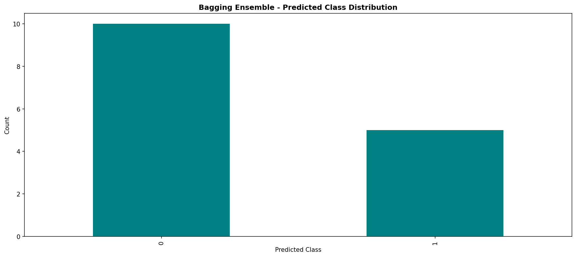
Figure 1

